EMERGENCY ACTION PLAN

Potomac Chinese School

8935 Bradmoor Drive
Bethesda, Maryland 20817
Approval and Implementation

Emergency Plan

This Emergency and Crisis Response Plan is hereby approved. This plan is effective immediately and supersedes all previous editions.

__Cynthia Kong___________________________ ______10/18/2011___
PRINCIPAL DATE

________________________________________ __________________
SCHOOL BOARD DATE

________________________________________ __________________
DATE

________________________________________ ___________________
DATE

________________________________________ __________________

DATE

________________________________________ __________________

DATE

________________________________________ __________________

DATE

________________________________________ __________________

DATE

1. Purpose

This Emergency Plan outlines Potomac Chinese School’s approach to emergency management and operations. It has been developed to assist Potomac Chinese School protect its staff and students during an emergency situation. This plan takes an all-hazard approach to emergency management and plans for mitigation/prevention, preparedness, response, and recovery.

2. Mission and Goals

The mission of Potomac Chinese School in an emergency/disaster is to:
    - Protect lives and property
    - Respond to emergencies promptly and properly
    - Coordinate with local emergency operations plans and community resources
    - Aid in recovery from disasters

The goals of Potomac Chinese School are to:
- Provide emergency response plans, services, and supplies for all facilities and employees
- Ensure the safety and supervision of students, faculty, staff and visitors to the school.
- Restore normal services as quickly as possible
- Coordinate the use of school personnel and facilities
- Provide detailed and accurate documentation of emergencies to aid in the recovery process

3. Building Information

The Potomac Chinese School is made up of ___1____ building(s).

The school consists of a main campus located at

8935 Bradmoor Drive, Bethesda, Maryland 20817

A map of the buildings annotated with evacuation routes, shelter locations, fire alarm pull stations, fire hydrants, fire extinguishers, first aid kits, hazardous materials storage, and utility shut offs is included in Appendix 1.

- Emergency Operational Guidance

A. Initial Response
A.1. School personnel are usually first on the scene of an
emergency situation within the school. They will normally take charge and remain in charge of the emergency until it is resolved and will transfer command and incident management to the appropriate emergency responder agency with legal authority to assume responsibility. They will seek guidance and direction from local officials and seek technical assistance from state and federal agencies and industry where appropriate. However, at no time will school officials transfer responsibility for student care.

A.2. The Principal will be responsible for activating the school emergency operations plan and the initial response which may include:
a. Evacuation – When conditions are safer outside than inside a building. Requires all staff and students to leave the building immediately.
b. Reverse Evacuation – When conditions are safer inside a building than outside. Requires all staff and student to go to safe places in the building from outside the building.
c. Lock down – When a person or situation presents an immediate threat to students and staff in the building. All exterior doors and classroom doors are locked and students and staff stay in their offices, work areas and classrooms.
d. Shelter-in-place – When conditions are safer inside the building than outside. For severe weather sheltering, students and staff are held in the building safe areas and interior rooms or basement away from windows. For hazardous material release outdoors with toxic vapors, students and staff are to remain in their classrooms, windows and doors are sealed and all ventilation systems are shut off. Limited movement is allowed. Taking shelter inside a sealed building is highly effective in keeping students and staff safe.
e. Drop, cover and hold – Students and staff drop low, take cover under furniture, cover eyes, head with hands and arms and protect internal organs.

B. Notification Procedures

B.1. In case of an emergency at the school facility, the Potomac Chinese School will immediately call 911 for help. The school will also immediately notify the Montgomery County assigned on-site security personnel.

B. 2. In the event of a fire, any one discovering the fire shall activate the building fire alarm system. Unless there is a lock down incident or a shelter in place incident in progress, the building shall be evacuated. In the event that a lock down or shelter-in-place incident is in progress, the evacuation shall be limited to the area immediately in danger from the fire.

B.3. In the event of a disaster when the building is no longer safe to return to, the Potomac Chinese School staff will call the parents of the students to pick up. The Potomac Chinese School staff contact information is listed in Appendix B.

B.4. The school maintains a book of the parent’s phone numbers at all times.

C. Parent/Child Reunification

The Parent/Child Reunification process will occur on school grounds in the parking lot in front of the main entrance or in the front lobby, depending upon the type of emergency. Parents must park in the school parking lot. The main entrance needs to be kept clear for emergency vehicles, equipment, and to maintain quick egress for everyone.
C.1. Signs will be posted to direct parents/guardians to the reunification area.
C. 2. Staff members will be available for assistance.
C. 3. Staff members will locate and release students to authorized individuals.
- 4. Students will be released to authorized individuals only.

D. Training and Exercise

D.1. Potomac Chinese School understands the importance of training, drills, and exercises in the overall emergency management program. To ensure that district personnel and community first responders are aware of their duties and responsibilities under the school plan and the most current procedures, the following training, drill and exercise actions will occur.

D.2. Training and refresher training sessions shall be conducted for all school personnel. In case of academic staff, training should coincide with the first in-service day of the school year. Training for the remainder of the support staff shall be held at a time during the school year that will allow for maximum attendance. Records of the training provided including date(s), type of training and participant roster will be maintained.

Appendix A: Floor Plan for Evacuation

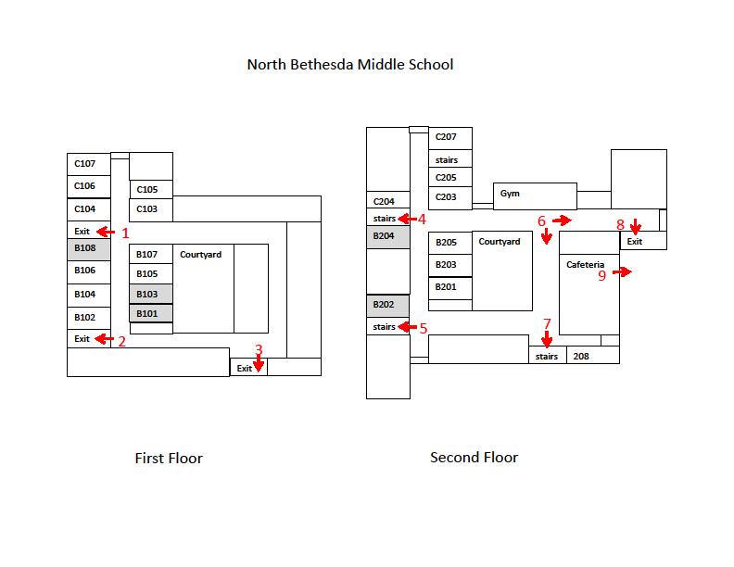
Appendix B: Potomac Chinese School Staff Contact Information

Name | Title | Phone | E-Mail
Principal | Cynthia Kong | 301-545-0505 | cynthia.kong@  potomacchineseschool.org
Vice Principal | Lee Guan | 301-765-8088 | lee_guan@yahoo.com
Secretary | Zhongfei Yu | 301-294-4920 | zhongfei_y@yahoo.com
Treasurer | Christine Xu | 301-880-1158 | christine_xu88@yahoo.com
School Business Director | Huaying Peng | 301-217-0810 | hpeng05@yahoo.com
Education Promotion Director | Henry Xu | 301-610-6592 | henryxu123@yahoo.com
Public Relation Director | Zhifang Liu | 301-765-3497 | fong_lz@yahoo.com
Recreation and  Culture Promotion Director | Qijian Song | 301-983-2502 | songqj@rocketmail.com
Admission and Registrar | Shirley Xu | 301-765-9085 | shirleyxu8@gmail.com
Teaching Director | Zizhen Liu | (240)453-9608 | zzliu_06@yahoo.com
Kindergarten (LangLang) Teacher | Xiaoyi Tian | (240)688-4471 | tianxiaoyi@hotmail.com
1st Grade (LangLang) Teacher | Qian Ning | (301)515-1003 | baoqian2000@yahoo.com
1st Grade (Ma Li Ping) Teacher | Renshu Zhang | (301) 765-9229 | renshu@hotmail.com
2nd Grade (Ma Li Ping) Teacher | Wendy Wang | (240)479-0589 | wendy9628@yahoo.com
3rd Grade (Ma Li Ping) Teacher | Yingxia Li | (202)841-9073 | kedilixia3@yahoo.com.cn
3rd Grade Teacher | Ning Lou | (301)838-7467 | linzhang_us@yahoo.com
4th Grade Teacher | Meizhen Wang | (240)505-7930 | mzwang2004@126.com
5th Grade Teacher | Hongying Wang | (301)358-0451 | jenniferhyw@gmail.com
6th Grade Teacher | Yuping Lin | (301)838-9767 | yp_lin@comcast.net
7th Grade Teacher | Weiwei Wu | (301)910-8831 | weiweiwu70@gmail.com
8th Grade Teacher | Qing Xu | (301)685-1478 | qingxu8235@yahoo.com
9th Grade Teacher | Hailun Ma | (301)340-7864 | hma4312@gmail.com
10th Grade Teacher | Diantao Sun | (301)765-9229 | diantaosun@yahoo.com
11th Grade Teacher | Jie Li | (240)821-4632 | jie_nn@yahoo.com
12th Grade Teacher | Songqiang Gao | (301)299-7291 | qko2006@yahoo.com
Billingual | Meilan Lin | (240) 449-5909 | milla.meilan@gmail.com

